Total list functoion=11

Adding:insert append extend

Removing: pop remove del

Copy:copy fun (by value ) wese hi assign by reference

Count ,index, reverse,sort,clear

#adding values into list {{Append and insert}}

cities=['Karachi','Lahore','Islamabad']

cities[0]

len(cities)

cities.append("Quetta")

cities

fruits=[]

fruits.append("Apple")

fruits.insert(0,'Mango')

#adding more than one values at a time means iteralble ho list ho

fruits.extend(['Orange','Strawberry'])

fruits

#count specific value

fruits.count('Orange')

#check index of paprticular

fruits.index('Orange')

#copy function copy its by value

fruits1=fruits.copy()

#in dono copy m farq h yeh by reference h "is m iska reference copy hota h naye value create nh hue ise list ko point krrha h jab k copy k function se value hi pore copy horhe h fruit or fruits3 dono ek hi ko copy krrhe h aga fruit m kuch add hoga toh fruit3 m bhi hoga"

fruits3=fruits

fruits.append("Banana")

print(fruits)

print(fruits3)

#removing an item from list

#del ka function index leta h

fruits=['Mango', 'Apple', 'Orange', 'Banana']

del fruits[0]

#remove ka fucntion value leta h

fruits.remove('Apple')

cities=['Karachi','Lahore','Islamabad']

cities.sort(reverse=True)

cities.

arr=[1,2,4,5,5]

arr.extend([1,2,3,4,5,6])

arr.extend(["apple","cherry"])

arr

arr.index("apple")

arr[1:4]

cities=['Lahore', 'Karachi', 'Islamabad']

'Karachi' in cities

Slicing:

#Slicing

#indexing   -5     -4       -3      -2       -1

students=["Ali","Faisal","Saleem","Hamza","Kashif"]

students[0]

students[2:-5]

***Tuples***

Has just two function count and index

#tuples are immutaa

atupple=(1,2,3,4)

atupple.count(1)

atupple.index(1)

a=12,45

print(type(a))

“LOOP”

for number in range(1,10,2):

  print(number)

for number in range(10,1,-2):

  print(number)

cities=['Lahore', 'Karachi', 'Islamabad']

for city in cities:

  print("The city under considertation is "+city)

for a in range(5):

  print("Inner LOOP begin")

  for char in 'china':

    print(a,char)

Table:

tableNumber=int(input("Enter table number : "))

for a in range(1,11):

  print(str(tableNumber) + " x " + str(a) + " = "+ str(a*tableNumber))

Nested LOOP

tables=int(input("Enter Table"))

for table in range(2,tables+1):

  for num in range(1,11):

    print(f"{table}*{num}={table*num}")

**Dictionary**

newDic={1:"Asad",2:"saad"}

newDic[1]

#deleting key value

del newDic[1]

#updating key value

myDic={}

myDict["email"]="mariums82@gmail.com"

aDic={1:100,2:200,3:300,4:400,1:1000}

#same key dene se previous key overwrite hojayegi

aDic

# o/p : {1: 1000, 2: 200, 3: 300, 4: 400}

#to check yeh key exist krti h ya nh

1 in aDic

#updating key value

myDic={}

myDict["email"]="mariums82@gmail.com"

aDic={1:100,2:200,3:300,4:400,1:1000}

#iterate krtey wqt 3 functions h

#1 - > .keys()

#2 -> .values()

#3 -> .items()

for key,val in aDic.values():

  print(key,val)

employee={'Name':"Shams","ChildrenNames":['Hram','Ebad' ]}

print(employee['ChildrenNames'][0])

#functions

def add():

  number1=int(input("Enter a Value"))

  number2=int(input("Enter a another Value"))

  print(number1+number2)

add()

**Data Files**

**To save data . code m generate hone wale chzein data file m write krwana h**

#with opne

#takes filename and mode --> w,r,a write,read,append

#writing to text file

#agar file majodo nh toh create hojayegii

#with open chlta h toh ek handler return krta h as file

with open("myFile.txt","w") as file:

  file.write("This is my file")

#reading from a text file

with open("myFile.txt","r") as file:

  content_of_file=file.read()

print(content_of_file)

with open("myFile.txt","a") as file:

  file.write("This text is written in append mode")

with open("myFile.txt","r") as file:

  content=file.read()

print(content)

#qk jab dobara write kregy toh file overwrite hojayegi toh islye we use apend is m file create nh hoti

#append file k end m data add krta h

#r+,w+ -- r+ write read dono hoskta h agar w m file create hoti h lkn r+  m expcetion ayega k file not found r or r+ m file ka create hona zarori h

#syntax --->  with open("filename",mode)

with open("testingDataFile.txt","w") as file:

  file.write("this is a test file ")

with open("testingDataFile.txt","r") as file:

  content=file.read()

content

################Mode#############

#reading mode

#writing mode

#append mode

#################################

with open("testingDataFile.txt","w") as file:

  file.write("Hello Dataa")

"""

with open("NonExistFile.txt","r") as file:

  file.read()

"""

#agar file nh h toh file not found ka error ayegaa agar hum ise w mode krde toh chl jayegaa

#if files dones not exit w mode will create and wrote in it

with open("NonExistFile.txt","w") as file:

  file.write("Non exit file data")

with open("NonExistFile.txt","a") as file:

  file.write(" Appended text")

with open("NonExistFile.txt","r") as file:

  content=file.read()

content

"""

r+ -->modifiled version of r (read)

w+ -->modifiled version of w (write)

"""

with open("newFile.txt","w+") as file:

  file.write("now created file w mode m file write hoti h read nh but w+ m read bhi hogi")

  file.seek(0)

  print(file.read())

  #write hogaya  file m  par read m kuch print nh horha

  #qk write hone k bd se read shuru krta h abhi agey koi content nh islye kuch show nh horhaa toh use function file,seel(0)

  #ab yeh dobara 0 index se reading krrha h

with open("newFile.txt","r+") as file:

  file.write("this is added text1")

  file.write("this is added text2")

  file.write("this is added text3")

  file.seek(0)

  print(file.read())

**Modules:**

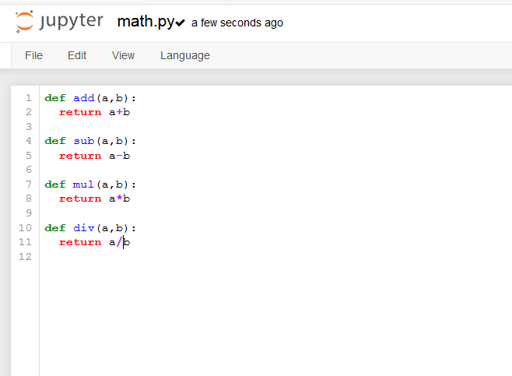

#class k andar function hotey h class ka size bhtt barh jataa h

#function dkhne or smjhne m muskil hoti h toh jo silenet function ko alag python ki file m rkhdo toh avaible bhi hojayegy or safe side pe bhi rahegy

#modules ko classes m imort krwa kr use kregy

#its makes class easy

**CSV**

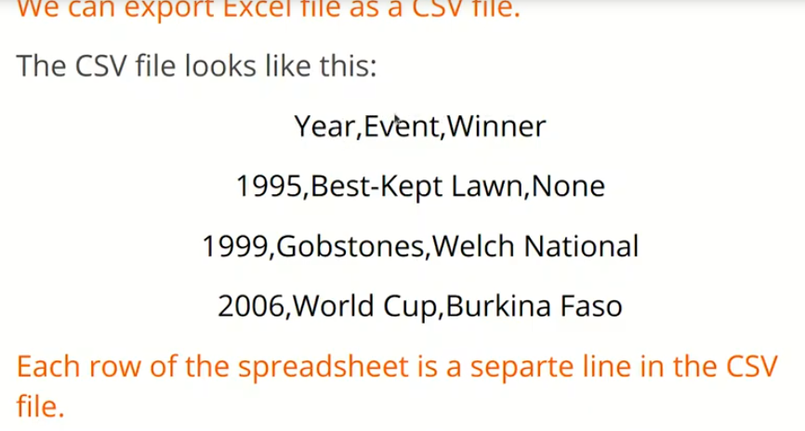

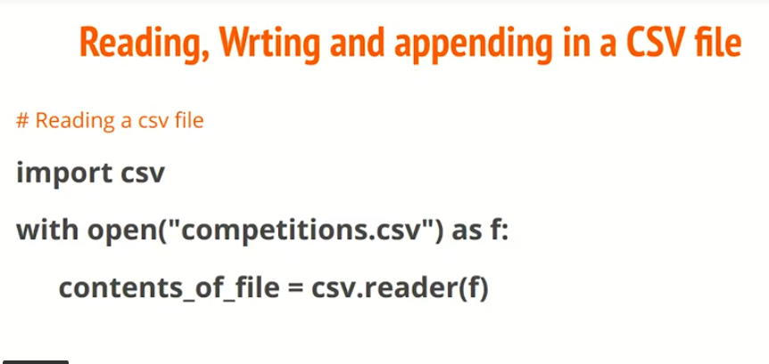

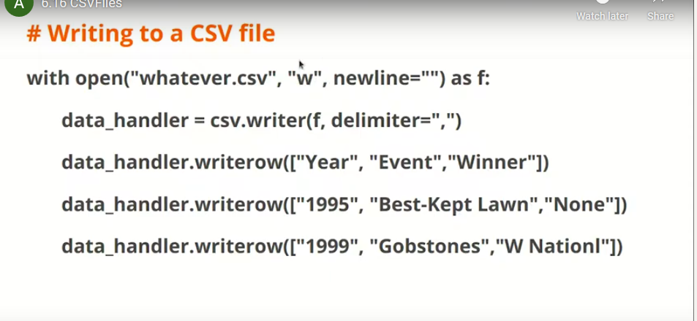

**#CSV**

**#comma seperated values**

**import csv**

**with open("whatever.csv","w",newline="") as f:**

**data_handler=csv.writer(f,delimiter=",")**

**data_handler.writerow(["Year","Event","winner"])**

**data_handler.writerow(["1995","Best-ket Lawn","None"])**

**with open("whatever.csv","r",newline="") as f:**

**content_of_files=csv.reader(f)**

**#ab jo data milega wo use form m nh hoga toh looping j t k thorugh acces kregy**

**#line by line list ki shakal m extract krna**

**content=[]**

**for data in content_of_files:**

**content.append(data)**

**content**

**import csv**

**with open("abc.csv","r",newline="") as file:**

**contents=csv.reader(file)**

**print(contents)**

**content=[]**

**for content in contents:**

**print(content)**

**content**

**with open("xyz.csv","w",newline="") as file:**

**fileWriter=csv.writer(file,delimiter=",")**

**fileWriter.writerow(["2019","CW2019","England"])**

**JSON:Javascrit object notation**

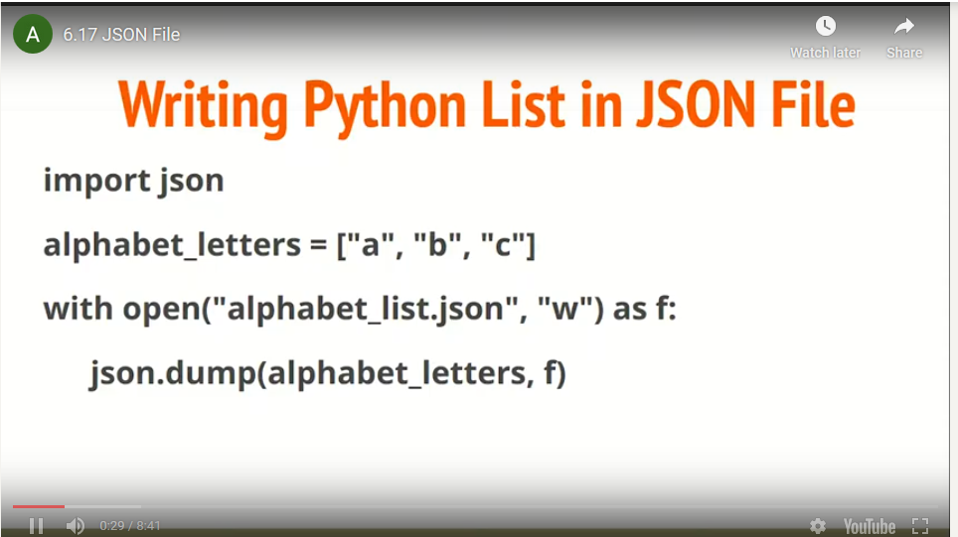

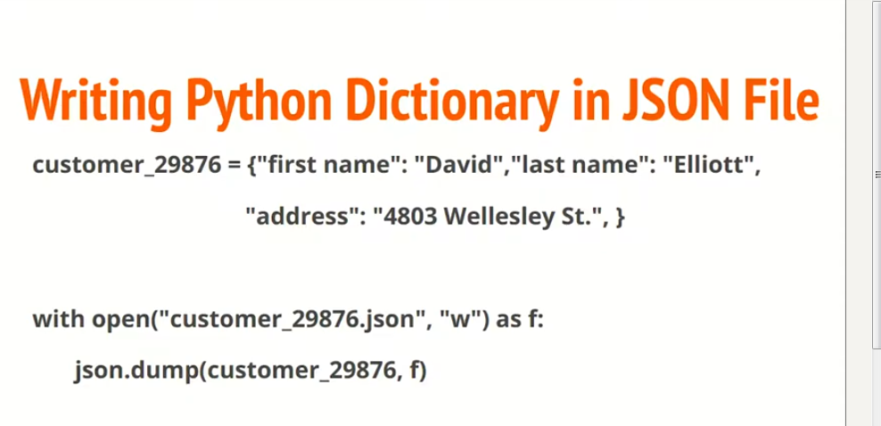

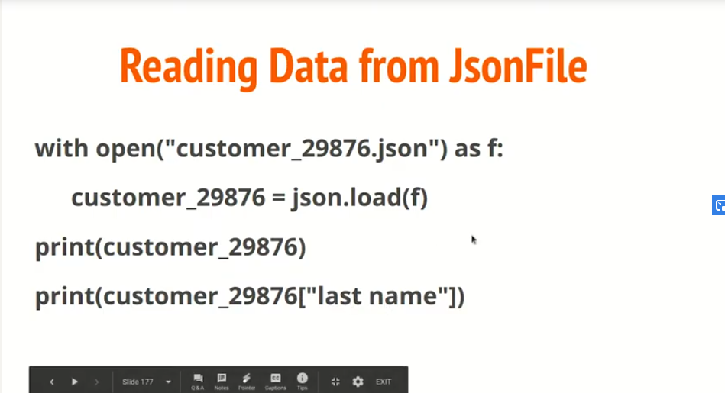

**#write -->Dump**

**#list ho ya dict json.dump kr k write read krwalo**

**#usually data dict m hota h like key,value pair**

**#read krne k lye load ka function h**

**import json**

**#writing data to json file**

**with open("jsonFile.json","w") as file:**

**json.dump([11,22,33,44,55],file)**

**with open("jsonFile.json","r") as file:**

**print(json.load(file))**

**#Reading**

**#yahan bhi override hoskta h je horha tha normally**

**#yaahn bhi apend chlta h**

**with open("jsonFile.json","a") as file:**

**json.dump(["a","b","c","d"],file)**

**#josn write**

**customer_29876={**

**"first name":"David",**

**"last name":"Elliott",**

**"address":"4803 wellesley St"**

**}**

**with open("dicFile.json","w") as file:**

**json.dump(customer_29876,file)**

**with open("dicFile.json","r") as file:**

**content=json.load(file)**

**content**

**Exceptions:**

**Runtimes error not syntax error jo compiler excute hone se phle pata chl jaye**

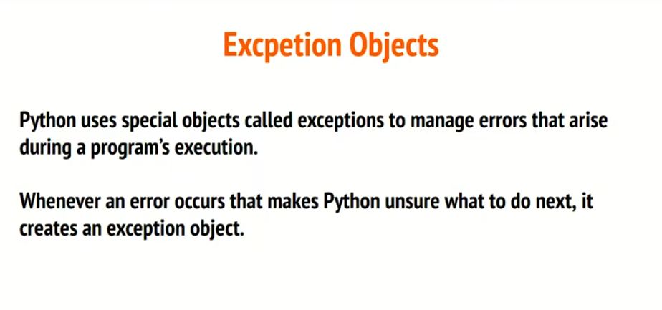

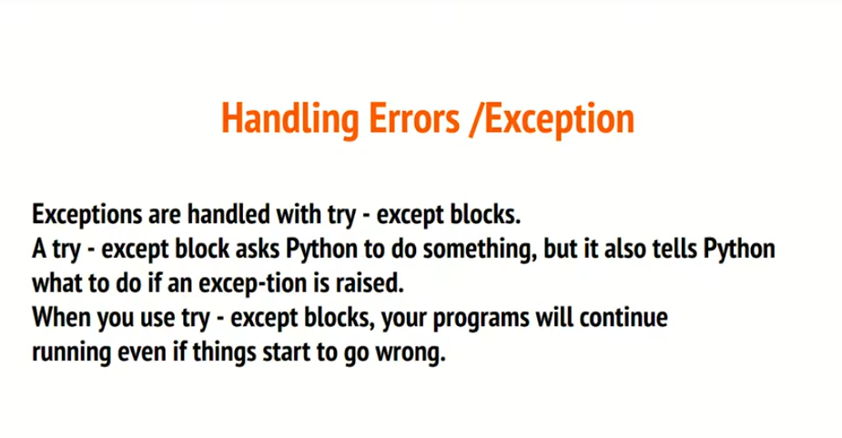

**Exception m agar koi expetional ata h toh kia krna h**

**Ek try k sth multiple expetions ho sktey h**

**#finally jo har hal m chlta h**